Tashyra Adams

DAD-220

Linda Wilson

09 September 2023

1. describe Employee;
2. Write the correct command to describe the Branches table

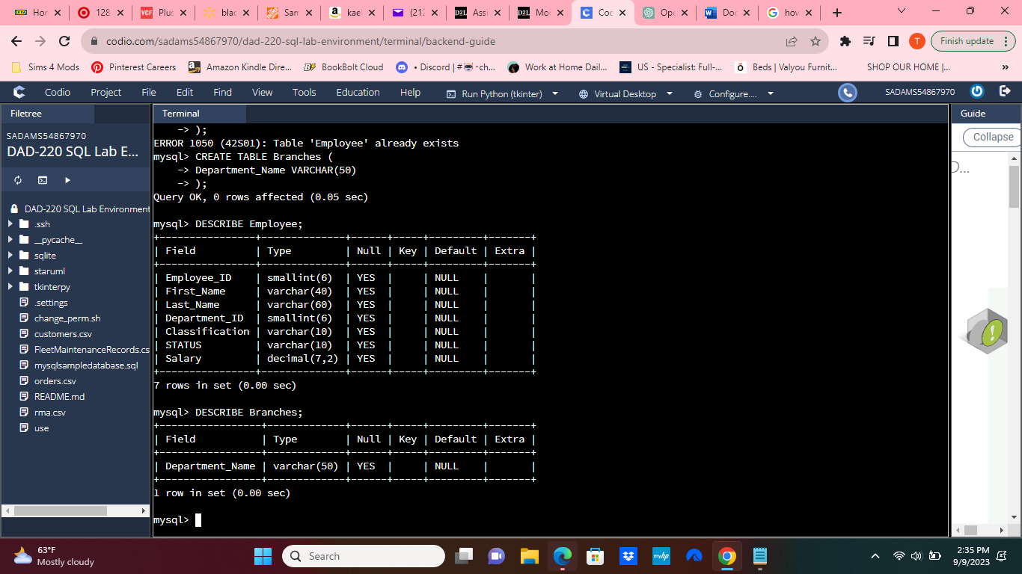

1. **Insert** the following **records into the Employee table (with support).**

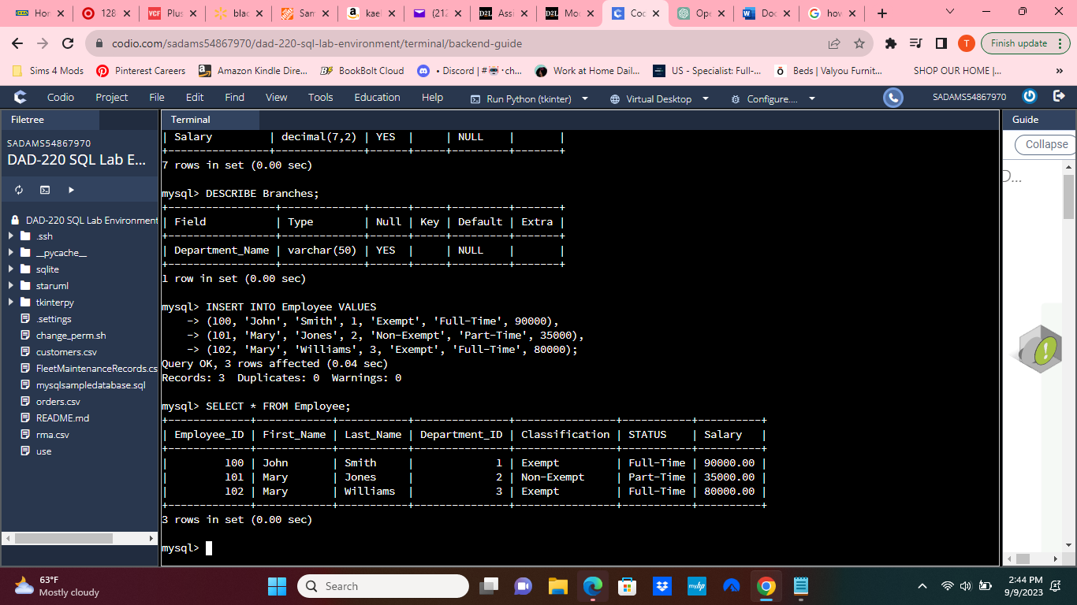

**Insert** the following **records into the Employee table** for Gwen Johnson and Michael Jones by writing the correct SQL commands on your own **(without support).**

1. Gwen Johnson: Employee ID = 103, DEPARTMENT_ID = 4, Classification = NULL, Status = Full-Time, SALARY = 40000
2. Michael Jones: Employee ID = 104, DEPARTMENT_ID = 4, Classification = Non-Exempt, Status = Full-Time, SALARY = 90000
3. Insert your name into the table to verify and prove your work

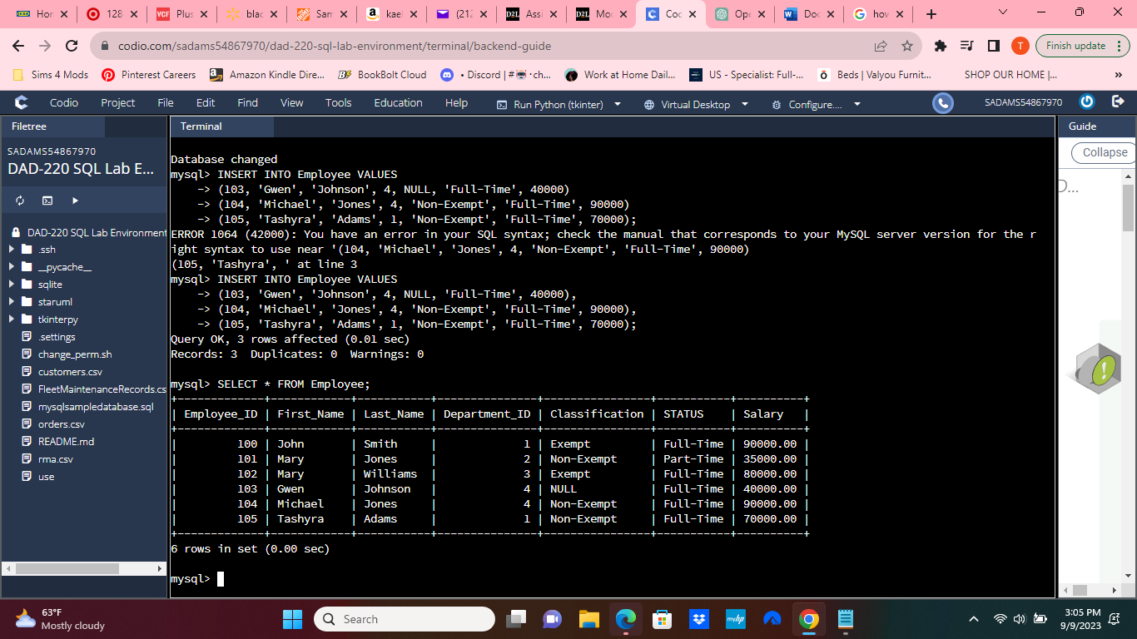

Insert records for a musician, athlete, or other famous character of your choice. Make sure to enter information for all of the fields listed in this table. The Department_ID must be a number between 1 and 4.

